JS Applications Exam - SoftTerest SPA
You are assigned to implement a Web application (SPA) using HTML5, JavaScript, AJAX, REST and JSON with cloud-based backend (Kinvey). Using libraries like jQuery, Handlebars and Sammy is allowed but is not obligatory. The app keeps users and ideas. Guests should be able to register and login. Logged-in users should be able to view all ideas, create ideas, like and comment ideas, see details about an idea and logout. Logged-in users should also be able to edit or delete the ideas they have created. There should also be a section where users can see only the ideas they have created.

Create a Kinvey REST Service
Register at Kinvey.com and create application to keep your data in the cloud.
Create a collection called ideas. Each idea has a name, description, organizer, comments and likes (starting from 0).
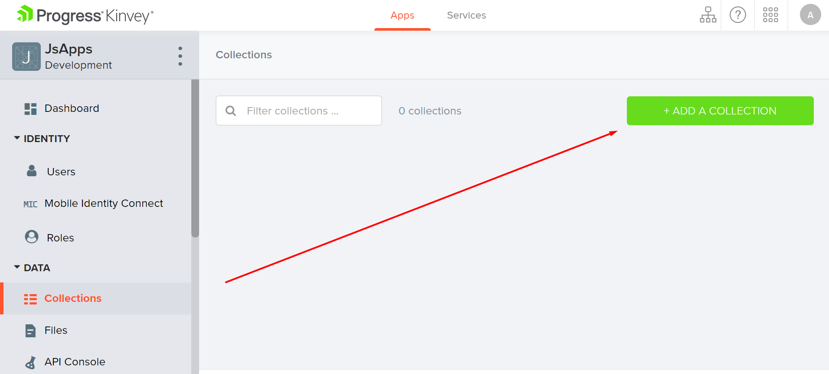
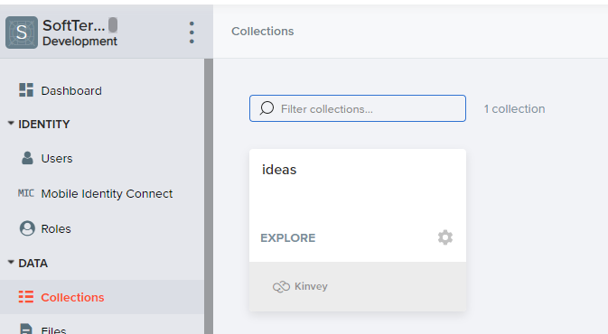
In order to be able to keep track of the likes and to add comments, you need to give all users permission to edit this collection. So, go to the properties of the collection.

Then go to the permissions and edit them to look like this:
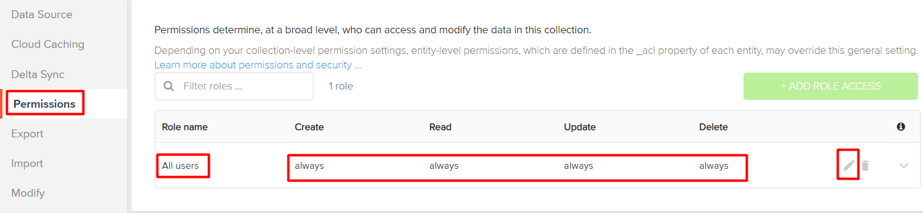

Test the Kinvey REST Services
Using Postman or other HTTP client tool (you can use Kinvey's built-in API Console), test the REST service end points:

User Registration (Sign Up)
POST https://baas.kinvey.com/user/app_id/
Request headers | Authorization: Basic base64(app_id:app_secret)  Content-Type: application/json
Request body | {  "username": "testuser",  "password": "testuserpass890"  }
Response  201 Created | {  "_id": "59930c78a743e20c7d3fca77",  "username": "testuser",  "password": "testuserpass890"  }
Error response  409 Conflict | { "error": "UserAlreadyExists", "description": "This username is already taken. Please retry your request with a different username", "debug": "" }
Error response  401 Unauthorized | { "error": "InvalidCredentials", "description": "Invalid credentials. Please retry your request with correct credentials", "debug": "" }

The request needs "Basic" authentication. Use the Kinvey App Key and App Secret as credentials.
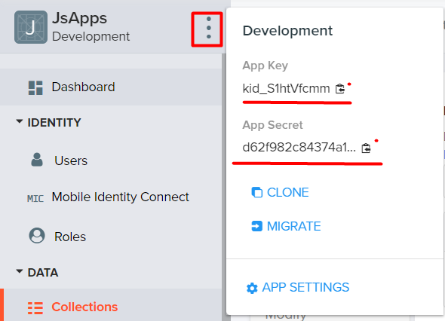

User Login
POST https://baas.kinvey.com/user/app_id/login
Request headers | Authorization: Basic base64(app_id:app_secret)  Content-Type: application/json
Request body | {  "username": "testuser",  "password": "testuserpass890"  }
Response  200 OK | {  "_id": "59930c78a743e20c7d3fca77",  "username": "testuser"  "_kmd": {  "authtoken":"8e6471bc-3712-4cfb-b92e-50e62a0c80….Duj5fHdM /7XHIe6KdY="  …  },  …  }
Error response  401 Unauthorized | { "error": "InvalidCredentials", "description": "Invalid credentials. Please retry your request with correct credentials", "debug": "" }
Successful login returns an authtoken which is later used to authenticate the CRUD operations.

User Logout
POST https://baas.kinvey.com/user/app_id/_logout
Request headers | Authorization: Kinvey authtoken
Response
204 No Content
Error response  401 Unauthorized | { "error": "InvalidCredentials", "description": "Invalid credentials. Please retry your request with correct credentials", "debug": "" }
To logout, you need to provide the authtoken given by login/register as "Kinvey" authorization header.

List All Ideas
GET https://baas.kinvey.com/appdata/app_id/ideas
Request headers | Authorization: Kinvey authtoken
Response  200 OK | [{  "title":"Dinner Recipe",  "likes":"0",  "description":"There are few things...",  "imageURL":"https://....",  "comments":"[]",  "creator": "peter.georgiev"  "_acl":  {  "creator":"5bfd4674682ae23931b4f91c"  },  "_kmd":  {  "lmt":"2018-11-28T15:25:24.521Z",  "ect":"2018-11-28T14:55:00.958Z"  }  }, …]
Error response  401 Unauthorized | { "error": "InvalidCredentials", "description": "Invalid credentials. Please retry your request with correct credentials", "debug": "" }

Create Idea
POST https://baas.kinvey.com/appdata/app_id/ideas
Request headers | Authorization: Kinvey authtoken  Content-Type: application/json
Request body | {  "title":"Dinner Recipe",  "likes":"0",  "description":"There are few things...",  "imageURL":"https://....",  "comments":"[]",  "creator": "peter.georgiev"  }
Response  201 Created | {  "title":"Dinner Recipe",  "likes":"0",  "description":"There are few things...",  "imageURL":"https://....",  "comments":"[]",  "creator": "peter.georgiev"  "_acl": {  "creator": "5bfd4674682ae23931b4f91c"  },  "_kmd": {  "lmt": "2018-11-28T15:39:58.801Z",  "ect": "2018-11-28T15:39:58.801Z"  },  "_id": "5bfeb6ce682ae23931bf7d26"  }
Error response  401 Unauthorized | { "error": "InvalidCredentials", "description": "Invalid credentials. Please retry your request with correct credentials", "debug": "" }

Edit Idea
PUT https://baas.kinvey.com/appdata/app_id/ideas/idea_id
Request headers | Authorization: Kinvey authtoken  Content-Type: application/json
Request body | {  "title":"Dinner Recipe",  "likes":"0",  "description":"There are few things...",  "imageURL":"https://....",  "comments":"[]",  "creator": "peter.georgiev"  }
Response  200 Ok | {  "_id": "59931398996ab5127d2a84d1",  "title":"Dinner Recipe",  "likes":"0",  "description":"There are few things...",  "imageURL":"https://....",  "comments":"[]",  "creator": "peter.georgiev"  }
Error response  401 Unauthorized | { "error": "InvalidCredentials", "description": "Invalid credentials. Please retry your request with correct credentials", "debug": "" }

Delete Idea
DELETE https://baas.kinvey.com/appdata/app_id/ideas/idea_id
Request headers | Authorization: Kinvey authtoken
Response  200 OK | {  "count": 1  }
Error response  404 Not Found | { "error": "EntityNotFound", "description": "This entity not found in the collection", "debug": "" }
Error response  401 Unauthorized | { "error": "InvalidCredentials", "description": "Invalid credentials. Please retry your request with correct credentials", "debug": "" }

Like Idea
PUT https://baas.kinvey.com/appdata/app_id/ideas/idea_id
Request headers | Authorization: Kinvey authtoken  Content-Type: application/json
Request body | {  "title":"Dinner Recipe",  "likes":"0",  "description":"There are few things...",  "imageURL":"https://....",  "comments":"[]",  "creator": "peter.georgiev"  }
Response  200 Ok | {  "title":"Dinner Recipe",  "likes":"0",  "description":"There are few things...",  "imageURL":"https://....",  "comments":"[]",  "creator": "peter.georgiev",  "_id": "5bfeb6ce682ae23931bf7d26",  "_acl": {  "creator": "5bfd4674682ae23931b4f91c"  },  "_kmd": {  "lmt": "2018-11-28T15:45:13.760Z",  "ect": "2018-11-28T15:39:58.801Z"  }  }
Error response  401 Unauthorized | { "error": "InvalidCredentials", "description": "Invalid credentials. Please retry your request with correct credentials", "debug": "" }

My Ideas
GET https://baas.kinvey.com/appdata/app_id/ideas?query={"_acl.creator":"${user_id}"}
Request headers | Authorization: Kinvey authtoken
Response  200 OK | [{  "title":"Dinner Recipe",  "likes":"0",  "description":"There are few things...",  "imageURL":"https://....",  "comments":"[]",  "creator": "peter.georgiev"  "_acl":  {  "creator":"5bfd4674682ae23931b4f91c"  },  "_kmd":  {  "lmt":"2018-11-28T15:25:24.521Z",  "ect":"2018-11-28T14:55:00.958Z"  }  }, …]
Error response  401 Unauthorized | { "error": "InvalidCredentials", "description": "Invalid credentials. Please retry your request with correct credentials", "debug": "" }

SoftTerest - HTML and CSS
You have been given the web design of the application as HTML + CSS files.
- Initially all views and forms are shown by the HTML. Your application may hide/show elements by CSS (display: none) or delete/reattach from and to the DOM all unneeded elements, or just display the views it needs to display.
- You may render the views/forms/components with jQuery or Handlebars.
Important: Don’t change the elements’ class names and ids. Don’t rename form fields/link names/ids. You are allowed to add data attributes to any elements. You may modify href attributes of links and add action/method attributes to forms, to allow the use of a routing library.

SoftTerest - Client-Side Web Application
Design and implement a client-side front-end app (SPA) for managing ideas. Implement the functionality described below.

(BONUS) Notifications (5 pts)
The application should notify the users about the result of their actions.
- In case of a successful action, a notification message (green) should be shown, which disappears automatically after 5 seconds or manually when the user clicks it.
- In case of error, an error notification message (red) should be shown, which disappears on user click.
- During the AJAX calls a loading notification message (blue) should be shown. It should disappear automatically as soon as the AJAX call is completed.
- NOTE: You get all the points if all the notifications have the exact content as described in each section above.

Navigation Bar (5 pts)
Navigation links should correctly change the current page (view).
- Clicking on the links in the NavBar should display the view behind the link (views are represented as sections in the HTML code).
- Your application may hide/show elements by CSS (display: none) or delete/reattach from and to the DOM all unneeded elements, or just display the views it needs to display.
- The Logged-in user navbar should contain the following elements: Icon (icon.jpg) which is a link to the Home page, [Create], [Logout].
  - The Icon should be a link that navigates to the currently logged in user’s profile.

- The guest users navbar should contain the following elements: : Icon (icon.jpg) which is a link to the Home page, [Register] and [Login].

Home Page (Guest) (5 pts)
The initial page (view) should display the guest navigation bar ("Home" (icon), "Register"and "Login") + Guest Home Page + Footer.

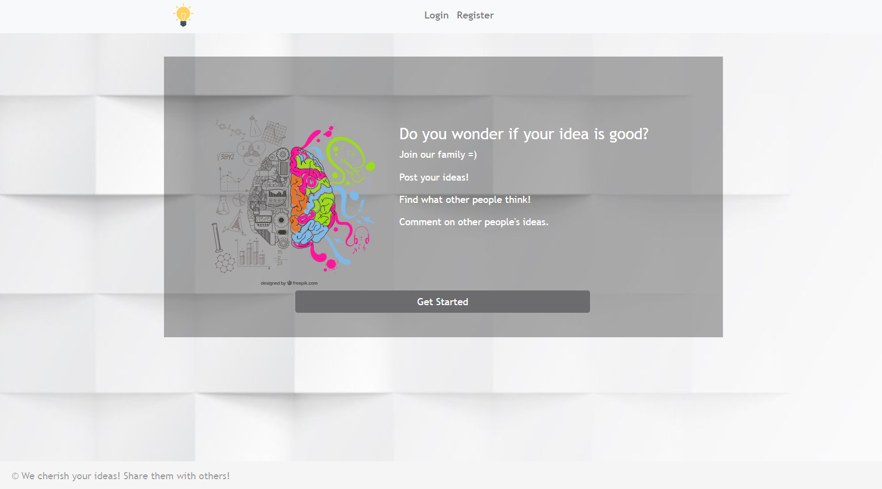

Register User (5 pts)
By given username and password, the app should register a new user in the system.
- (BONUS) The following validations should be made:
  - The username should be at least 3 characters long
  - The password should be at least 3 characters long
  - The repeat password should be equal to the password
- After a successful registration, a notification message "User registration successful." should be displayed and the app should redirect to the home page with the right navbar.
- In case of error (eg. invalid username/password), an appropriate error message should be displayed, and the user should be able to try to register again.
- Keep the user session data in the browser's local storage.
Register once and create/Like awesome ideas!

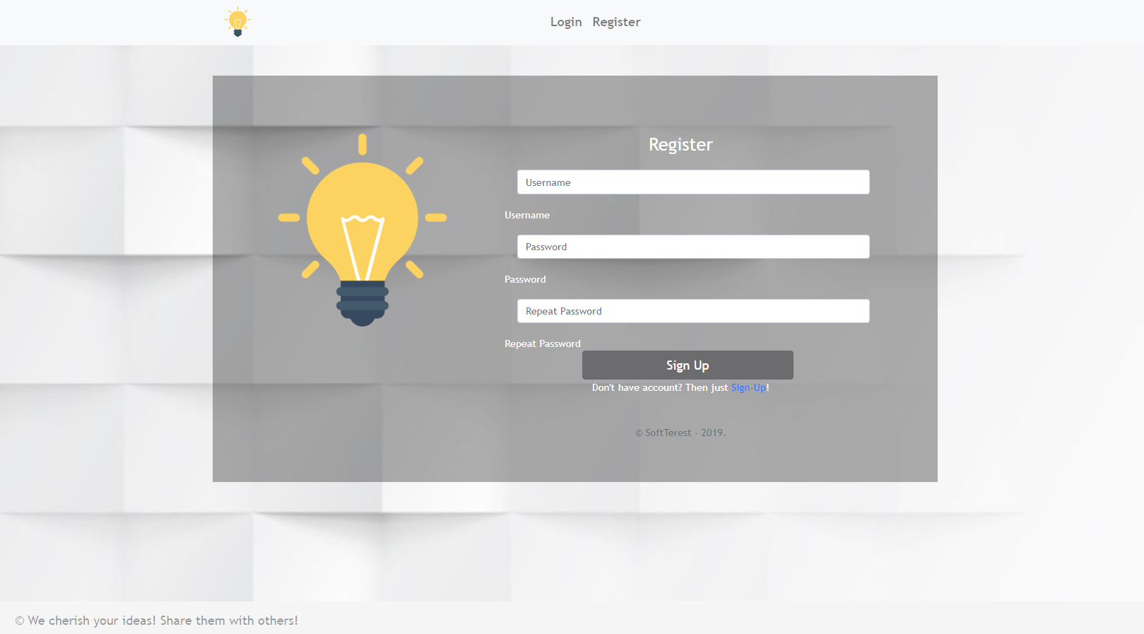
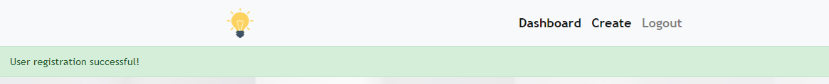

Login User (5 pts)
By given username and password, the app should login an existing user.
- After a successful login, a notification message "Login successful." should be shown and the user home screen should be displayed.
- In case of error, an appropriate error message should be displayed and the user should be able to fill in the login form again.
- Keep the user session data in the browser's local storage.
- Clear all input fields after a successful login.
You are one step away from awesome ideas!

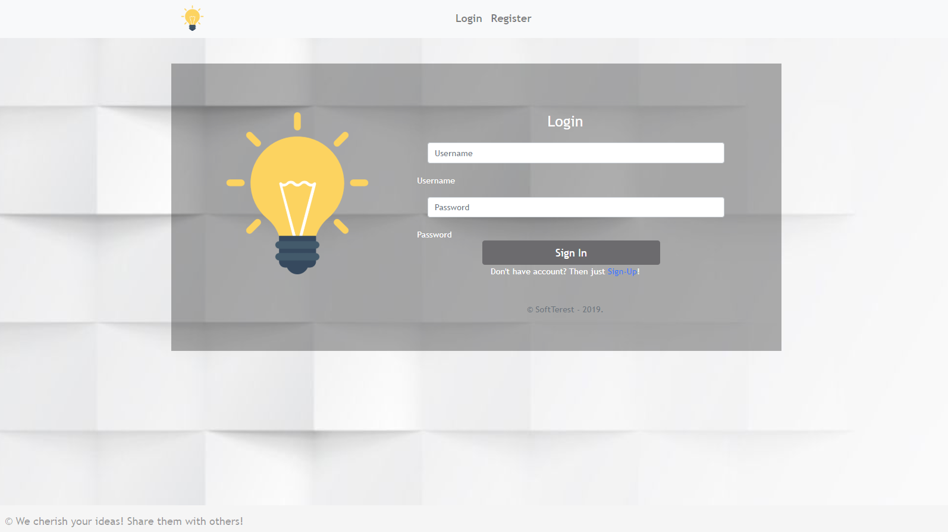
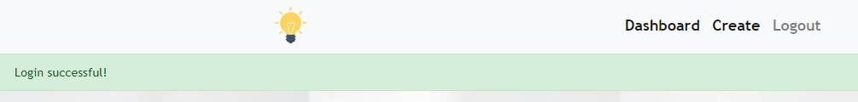

Logout (5 pts)
Successfully logged in users should be able to logout from the app.
- After a successful logout, a notification message "Logout successful." should be displayed and the anonymous screen should be shown
- The "logout" REST service at the back-end must be called at logout
- All local information in the browser (user session data) about the current user should be deleted
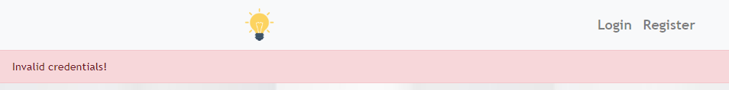
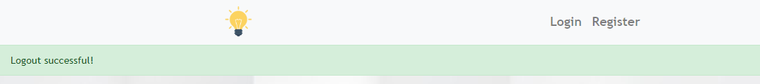

Dashboard (30 pts)
Successfully logged-in users should be able to see the Dashboard. They should be able to see all created ideas.
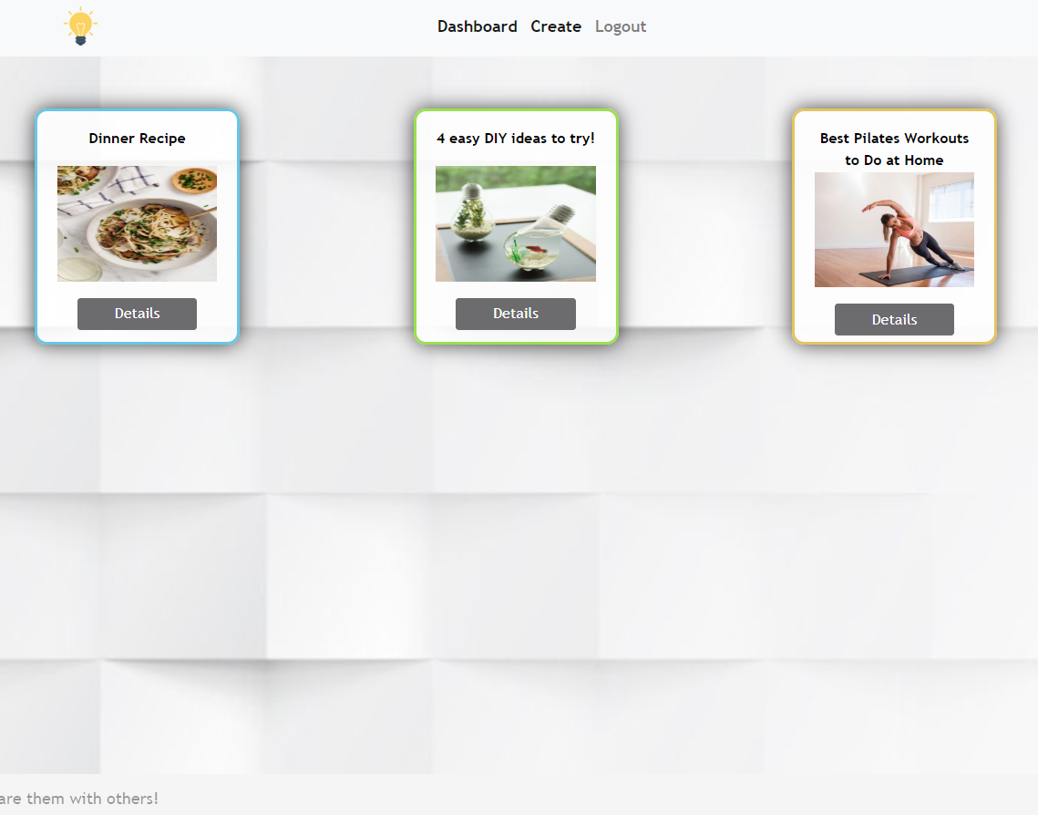
If there are NO such ideas, the following view should be displayed:
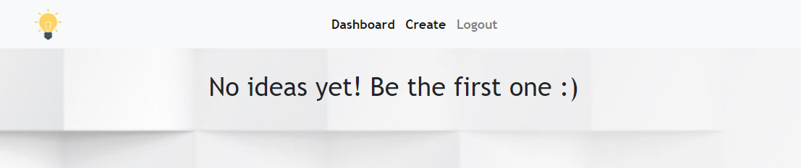

Create (10 pts)
Logged-in users should be able to Create ideas.
Clicking the [Create] link in the NavBar should display the Create page.
- (Bonus) The form should contain the following validations:
  - The title should be at least 6 characters long.
  - The description should be at least 10 characters long.
  - The image should start with "http://" or "https://".
  - By default, every newly created idea must have additional information:
    - Creator: string representing the current idea creator;
    - Likes: number starting from 0;
    - Comments: empty array
  - After a successful idea creation, a notification message "Idea created successfully." should be displayed and the Dashboard should be shown.
- The inputs fields in the form should be cleared.
- The newly organizer idea should be stored in the Kinvey collection "ideas".
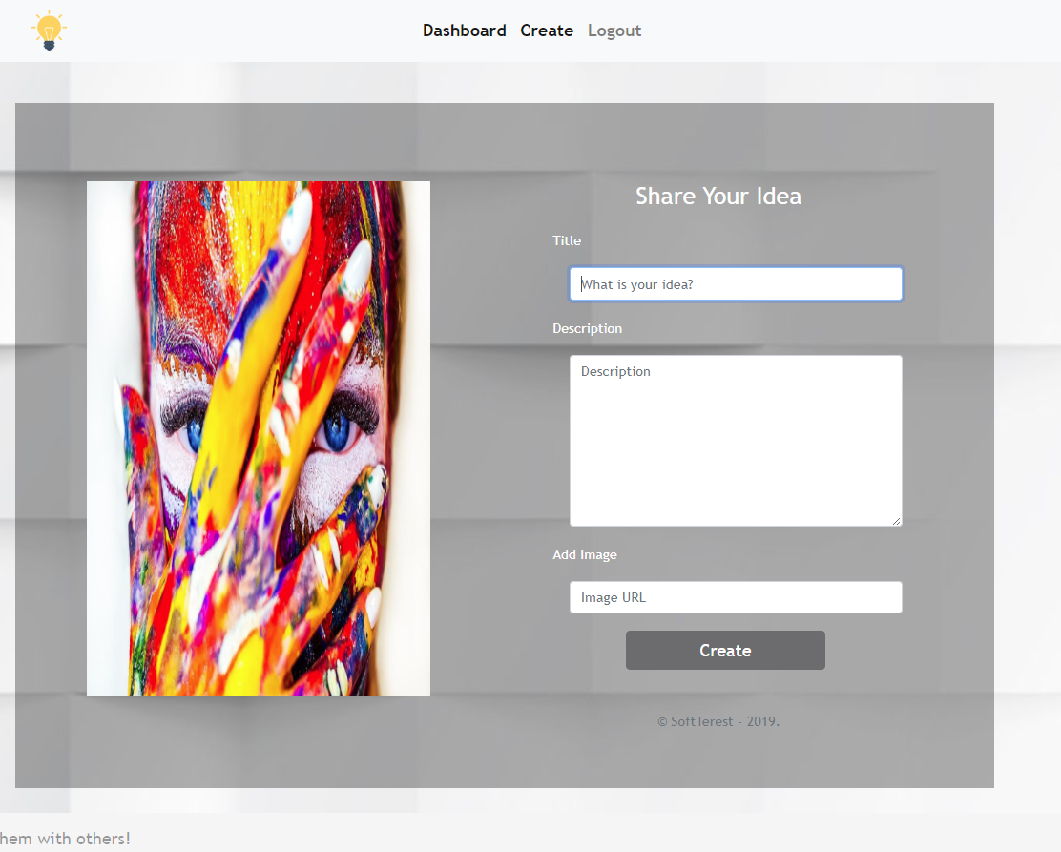
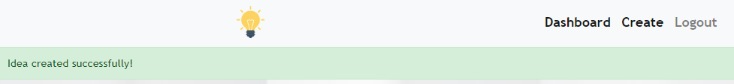
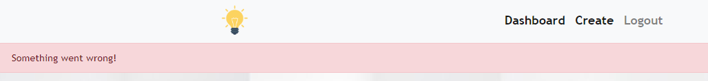

Details Idea (10 pts)
Logged-in users should be able to view details about ideas.
Clicking the [Details] link in of a particular idea should display the Idea Details page.
- If the currently logged-in user is the organizer of the idea, [Delete] button should be set to visible, otherwise there should be 2 buttons [Like] and [Comment].
- If there are no comments you should display "No comments yet"
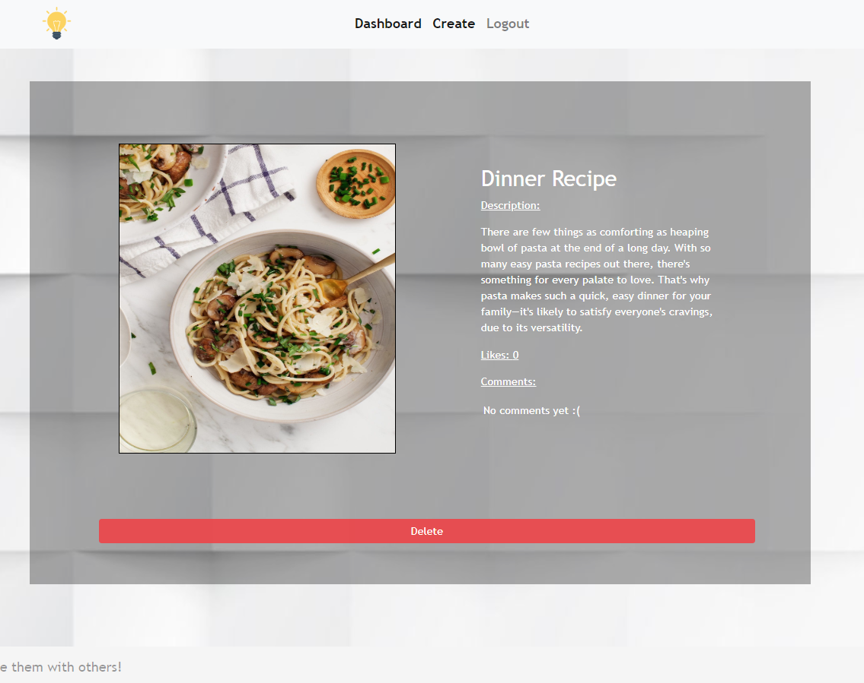
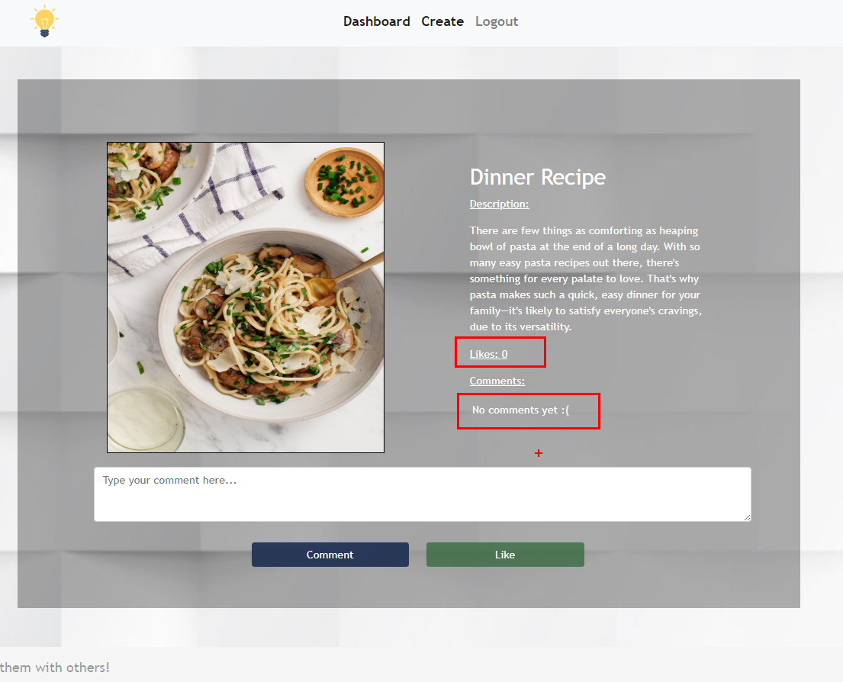

Comment on Idea (10 pts)
Logged-in users should be able to comment ideas.
Clicking the [Comment] link of a particular idea on the Idea Details page should get the comment from the textarea and display it in the proper section.
NOTE: A user should NOT be able to comment an idea, created by himself.

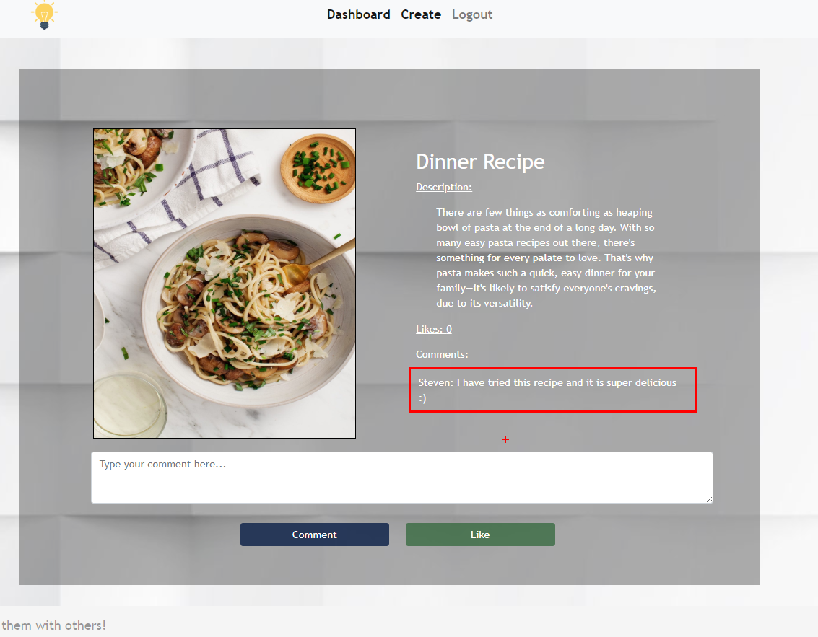
- Every comment shoud be displayed as follows: {current user} : {comment}

Like Idea (10 pts)
Logged-in users should be able to Like ideas, created by other users.
NOTE: A user should NOT be able to Like an idea, created by himself.
Clicking the [Like] link of an idea (on the Idea Details page) should increase the property for the likes of the corresponding idea.
Users can Like ideas multiple times.

Delete Idea (5 pts)
Logged-in users should be able to delete their ideas.
Clicking the [Delete] link of an idea (on the Idea Details page) should delete the idea.
- After successful idea delete a notification message "Idea deleted successfully." should be displayed and the Dashboard should be shown
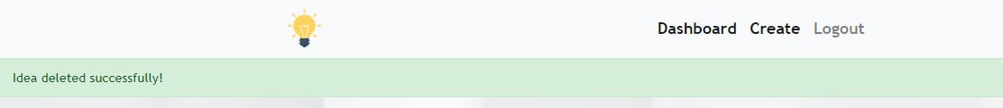

(BONUS) Profile Page (5 pts)
Logged-in users should be able to view their profile.
Clicking the Icon link on the navigation bar should display the
User Profile page:
- Each user profile should display user info - profile picture, username and ideas information
  - "Has {count} ideas"
  - The names of all ideas which the user has created.
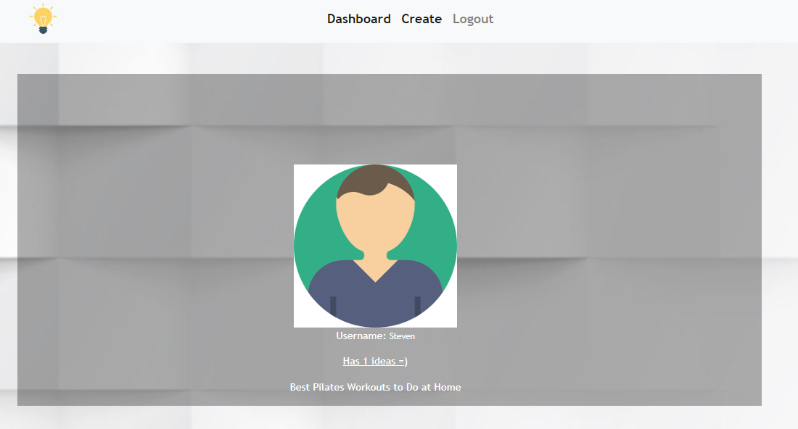

- In case of no ideas, display "No ideas yet".
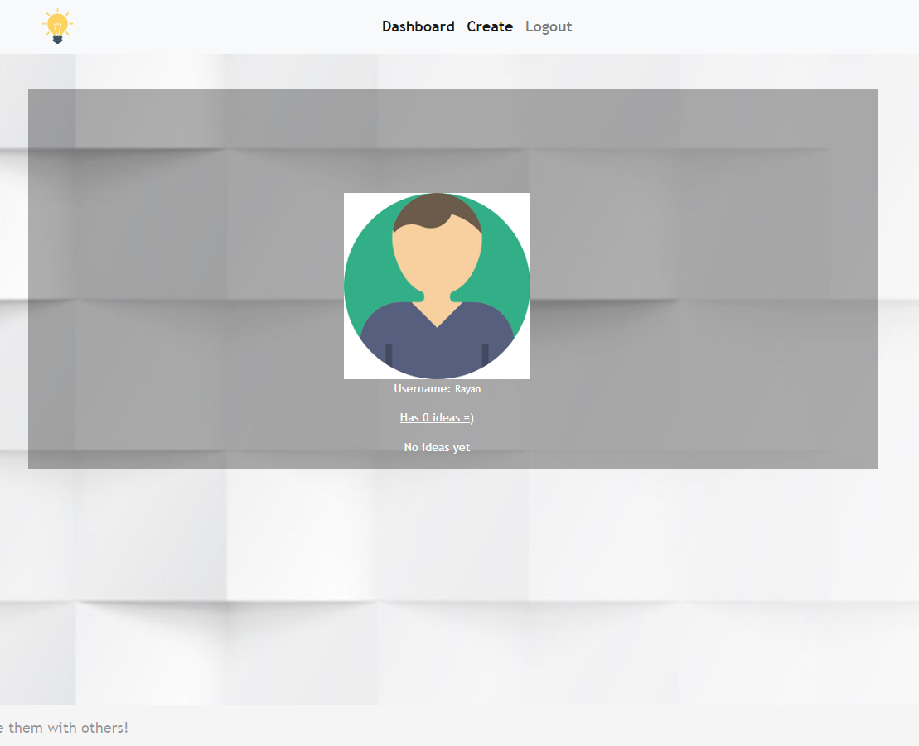

(BONUS) Sorting: (5 pts)
The ideas in the home page (for registered users), should be sorted in descending order by likes.

Submitting Your Solution
Exclude the node_modules folder and ZIP your project. Upload the archive to Judge system.

